The Great War

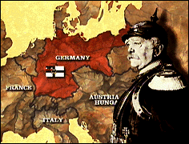
The German Empire was young in 1914. It came into being following a series of wars in 1871.

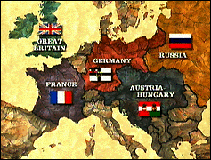
German Chancellor Otto von Bismarck’s adage was always to be in a majority of three in any dispute among the five great European powers. His aim was to preserve Germany’s peaceful ties with Russia.

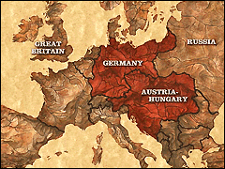
Kaiser Willhelm II quickly upset Bismark’s delicate balance of power. Germany, by refusing to renew its friendship with Russia, soon found itself in a minority of two. Its only European ally, was the weakest of the European powers, Austria-Hungary.

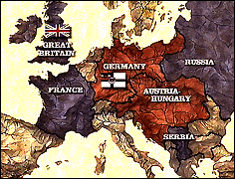
The tripwire that set off the century’s first global conflict was Austria's declaration of war against Serbia on July 28, 1914. A war between Austria and Serbia meant a war between Austria and Russia, Serbia's traditional ally. That meant war between Russia and Germany. And that meant war between Germany and France. And that meant war between Germany and Great Britain. In a flash, the whole continent was at war.
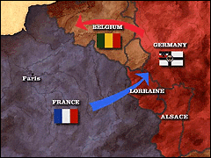
The Schlieffen Plan required precision timing. In the east, the Russian army was to be held at bay. In the west, the German army would avoid France’s line fortifications by sweeping west through neutral Belgium and then turning in a huge arc south into France. The French army would be destroyed defending Paris.

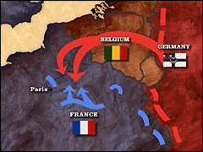
Believing that Germany's advance into Belgium was a diversion, most of the French army moved northeast to attack Germany through the lost provinces of Alsace and Lorraine. The first major battle on the Eastern front occurred when German forces surrounded and destroyed Alexander Samsonov's Russian army at the Battle of Tannenberg. This August 1914 engagement proved to be Germany's greatest victory of the war. German plans for the Western Front soon began unraveling. As the German right flank drove deeper, it separated from the rest of the invading force. Recognizing their vulnerability, the Germans pulled up twenty-five miles short of Paris. Now, it was France’s chance to attack. What followed was the Battle of the Marne where the German advance was stopped.

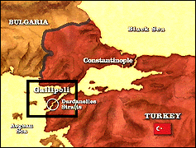
On April 24th, 1915, an amphibious force of British, French, Australian, and New Zealand troops began landing on the Turkish peninsula of Gallipoli. Their aim, to knock Germany’s ally, Turkey, out of the war. Only a small Turkish force awaited them on the cliffs overlooking the shore.

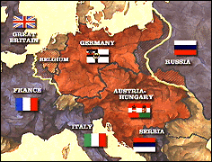
After two years of war, the battle lines of the Western front (noted in yellow) had barely changed from the first days of stalemate. This was modern warfare. The Eastern front was a different story, where battles more resembled fluid engagements of the 19th century.

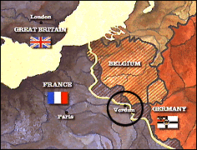
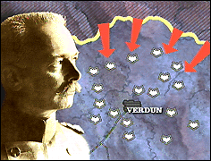
German General Erich von Falkenhayn developed a battle plan for attacking Verdun, France, a city protected by aring of underground forts.

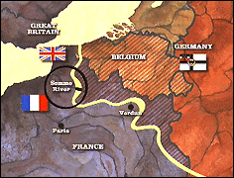
One hundred and twenty-five miles northwest of Verdun, the British and French armies joinedat the Somme river. A Franco-British offensive wasplanned here for 1916 to relieve pressure on the French at Verdun.

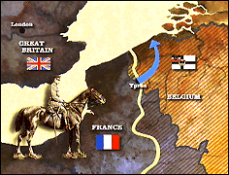
British General Douglas Haig often believed his army was on the verge of a breakthrough. His optimism resulted in a plan in 1917 to attack the German lines just outside of Ypres, Belgium. Breaking through, his army would sweep across the low plains and swing north to the sea. The attack was mired by mud and rain. The ambitious plan yet another failure.

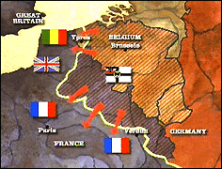
Over four months in 1918 the German army launched five major assaults at different parts of the allied line. Initially the plan worked. The British Fifth Army collapsed. The allies gave ground. But for every allied trench captured, there was always another for the Germans to take. Soon the elite German storm troopers were a spent force. In desperation Ludendorff resorted to the old and murderous tactic of mass assault.

